**GetItDone: Giving Students Time Management Tools to Reduce Stress and Improve Control of Time**

**INFO 4400 - P7 Final Report**

**Group 5: Ryan Curtis (rec284), Grace Song (gs488), Ezra Truneh (eat84), Shauna Cheatham (snc59)**

Word count: **3498** (reduced as much as possible)

**Outline**

**Abstract:** **2**

**Introduction:** **2**

**Design objectives and/or research questions:** **6**

**Study I: Diary Studies** **6**

Method 7

Findings 8

**Initial Design:** **9**

**Study II: User Enactments** **10**

Method 10

Findings 11

**Final Design:** **11**

**Discussion:** **12**

**Conclusion:** **13**

**References:** **14**

# Abstract:

Our project is focused on how college (specifically, Cornell University) students keep track of their tasks and manage their time in order to complete their obligations. We have found that generally, students do not have an enjoyable experience managing their time and workload. For our project, we worked towards creating a design solution able to help college students manage their workload in such a way that would lead to a productive and balanced lifestyle. Our app processes the student’s assignment and event data from multiple sources. Then, it generates a suggested breakdown of time to be spent on each task with a suggested schedule for that day, and allows them to modify or adjust the proposed schedule to more closely fit their needs. In pursuit of our goal, we conducted multiple user research studies. In our diary study, we learned a lot about how students keep track of their tasks on a daily basis and how they feel about completing different kinds of tasks. Using the collected data, we formulated ideas for a potential design solution and created a prototype which we tested with our second user research method, a User Enactments session. We incorporated the students’ insights and suggestions into our final prototype.

# 

# **Introduction:**

We have found that generally, students do not have an enjoyable experience managing their time and workload due to busy lives, with a lot of commitments and tasks to do. While it is impossible for our project to reduce workload, we can have an impact on how they go about completing their work. Ask any college student and they will tell you that they have infinite workload. However, task management and the way students use their time can play a substantial role in how students *feel* about their workload. To change workload directly would be a truly wicked problem. However, we saw an opportunity to have a meaningful impact on the daily stress levels and attitudes of students. For our project, we worked towards creating a design solution able to help college students manage their workload in such a way that would lead to a productive and balanced lifestyle. In essence, our solution is a time management mobile app. We hope that our solution will contribute to a more enjoyable way to manage students’ time to reduce some of the stress and offer a balance between flexibility and structure to help students thrive in their day-to-day lives.

**Background:**

When trying to understand the space of time and task management amongst college students, it is clear that many students are overly stressed by a variety of factors. A study by Britton and Tesser indicated that the level of control over one’s time management was correlated to grades and many students struggled with efficiently managing their time for lots of different assignments and commitments (Britton et al., 1991). This implies that many students could benefit from some assistive technology to help with time management. Another study was done by Nonis et al about college students’ stress levels and the amount of perceived control over time management. The study showed this is a method to help reduce stress in college students (Nonis et al., 1998). This will lead us to explore how students are currently managing their time and tasks through a diary study to see what areas can be designed for to reduce stress with an assistive technology. In order for an assistive technology to be successful, each one should be personalized and catered to an individual user, as well as understand and predict what users want done. A study done by Kwon and their team showed that enabling predictive capabilities in the social robots enabled them to respond faster to requests to minimize wait times for both human users and robots (Kwon et al., 2013). This is done to improve efficiency and the user experience using a hybrid temporal Bayesian Network for making probabilistic models for predicting causality and time of upcoming actions (Kwon et al., 2013). Another example of a smart device is PExA – a system that “is associated with a single user, but interacts with the PExAs of other users to exchange information and coordinate on tasks” (Myers et al., 2007). PExA gains its knowledge from the user’s personal calendar, an email server, user preferences, and taxonomy of general office concepts (Myers et al., 2007). Both of these technologies shows us how the systems grasp the needs of the users, so they can deliver immediate results at the users’ commands.

To show how much personal assistants can be personalized, we wanted to research the different types of users (other than college students) who may also use smart devices for task management, especially to broaden our scope of whether or not smart devices are the best tool for task management. Scherer talks about how assistive technologies, in conjunction with other supports, can help individuals with cognitive disabilities. Those with cognitive disabilities often times do not remember what tasks they must do - therefore, they cannot learn to incorporate certain tasks into their daily routine. Assistive technologies can “aid in modifying behavior problems like impulsive decision-making and poor management of daily routines” (Scherer, 2009).

Another issue is that the public is unsure whether or not personal assistants are a better solution for task completion. there is current research being done about how voice-activated personal assistants differ from GUIs in the experience they create beyond task completion time. They research uses a task completion on both a GUI interface and a voice assistant and then recording data on how the participants use the different types of interfaces for different tasks or in different situations (Simpson, 2019). This means we should consider the different types of interactions through a user enactment to make sure the interfaces are fit for the user and various scenarios.

In order to gain insight and data about task management, we have decided to conduct a diary study. This was the best study method because since the act of task management is done daily and the potential use of smart assistants will also be an everyday occurrence, we believe that it was most appropriate to gain insight about how college students manage their tasks on a day-to-day basis.

This research presented, in conjunction with other literature we have read, have given us some insight into a tool that college students can utilize for task management. As society moves forward into a technological deterministic society, people are bound to turn to technology for a majority of things – including task management. Additionally, the research shows that with a qualified smart assistant, the issue with task management can be solved for those who need the extra support in their daily routines. Just like how the technology can help those who are cognitively disabled, the technology will of course help those who have the ability to remember what tasks and when their supposed to be done when the technology manages their schedule for them. The research also helped us formulate what design solutions would be possible to create an improved smart assistant that could be more predictive to the user’s needs in managing and completing tasks whereas many current technologies are purely reactive to user input. There is a strong emphasis on the importance of predictive technology that will be incorporated into our design choices to create a better smart assistant.

# Design objectives and/or research questions:

Our project is based on improving the student experience at Cornell by building tools to help manage and complete tasks in a busy life where the student is always on the move between classes, work, meeting, etc. In looking at how to help manage tasks we hypothesized that a personalized smart assistant would be useful to send friendly reminders and support the student throughout a variety of contexts. We also considered the importance of having a GUI rather than just a voice interface. More importantly we wanted to look at ways to help students manage tasks in a way that removes some of the stress by introducing assistive technology to make a more enjoyable experience. These goals and questions are based in our research of time and task management as well as current solutions.

# 

# Study I: Diary Studies

## Method

The goal of this study is to better understand how students currently manage their schedules through various applications and strategies. We also want to understand how they balance their social needs with their academic needs, and how they decide when to complete an assignment. Additionally, we wanted to capture their feelings about how they felt in the moment about completing different kinds of tasks.

Our participants were five undergraduate students, four of them from Cornell University. We recruited them by asking people in our class to participate and asking friends of friends to participate in a study. This way, we maintained a layer of personal separation from our participants while still having them be in our planned target audience (undergraduates). All of our participants are in their final year of undergraduate work.

We briefed participants by telling them about the goals of the study and what would be expected of them. The study was to be conducted over the course of three full days, and students would log an entry every time they either planned or completed a task. They would log entries using a Google Form that they were all given a shortened link to. We performed introductory and exit interviews to gather an extra layer of detailed data before and after the study. Our data analysis technique was to collect all the data in a spreadsheet and, in a group, distill common points onto a whiteboard. From there, we visually drew connections between different points and identified common problems and moods towards re-occurring types of tasks.

## Findings

Through the analysis of our diary entries, we found that users complete nearly all tasks that they plan. Each of the tasks our users entered into their diary study ended up being completed. We also found that students had a negative feeling about having to complete academic tasks, but felt positively about social tasks. We found that social tasks are planned more impromptu than formally planned. We also found that our participants use different planning methods based on the task type; there was no one universal method for planning all tasks. For example, a user may plan academic tasks by writing them in their planner, but social tasks by adding it to the calendar on their phone. Users feel positively about completing a task, independent of what the task was and how they felt about having to complete it. This shows us that users like the feeling of getting tasks done. We also found that users enjoy planning social tasks.

Our diary studies included a pre-interview and post-interview, which we also analyzed to better understand how students plan their tasks and their attitudes towards voice assistant technology. Through the interview, we found that how students plan their tasks depends on context; what they use to remember and plan for a certain task depends on what they have around them at the time. For example, if a student has their notebook with them, they may write a note to themselves to remember later on. If a student has their phone, they may use their calendar or a notes app. We also found that many users prefer writing tasks down to remember them because the physical act of writing something makes the task more tangible for them. We found that students don’t like to procrastinate their tasks, and feel more in control when they break up large tasks into smaller parts. While some of our users plan academic and social tasks using the same methods, other plan them separately using different methods. The more tasks that students have, the harder it is for students to manage them. Users also prioritize academic tasks over social task, often to the detriment of their social life. Many of our users wished they had more time to spend with friends and do things they enjoy, but found their academic workload too extensive to balance with their social needs. Users explained that they like to break up large projects into smaller, more manageable tasks. They also enjoy rewarding themselves for completing tasks with food. Our participants have difficulty using current personal assistants like Siri because they are limited in their capabilities and the type of information they can give, and because of this they do not use voice assistants regularly.

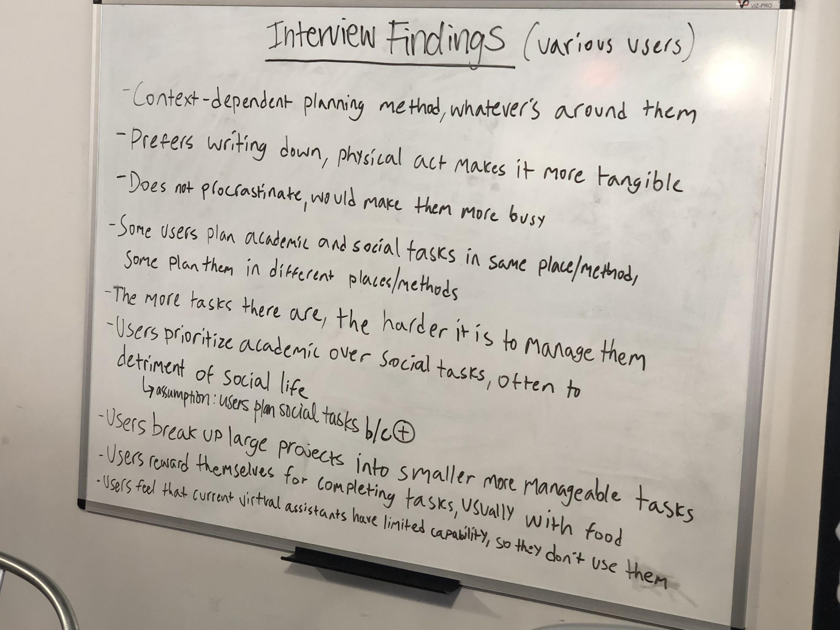

# 

# Initial Design:

Our initial application was called GetItDone, an app to help students budget their time throughout the day in order to be more productive, organized, and to help students fit social activities into their daily schedules. The home screen showed an hourly breakdown of the day where students could see their activities and budget their time by hour. In the settings, students can sync their app with their calendars and Cornell scheduler to automatically have their tasks in one place. These are apps that users told us they use to plan tasks. The app also had a pie chart coded by color that showed students a breakdown of their day. Larger pieces of the pie represented activities that would take up more time during that day. This was to help students think of time differently, tasks being pieces of their day, instead of linearly, and to see a visual breakdown of where they should be spending the most of their time. The chart changes each day depending on the student’s tasks for that day. Students can also add recurring activities so that the app will remember their plans for each day. The app pairs with bluetooth devices, like earbuds and headphones so that a voice smart assistant can remind you of your tasks, when to take a break, and add tasks that you tell it to add. This is meant to mimic a human personal assistant that can remind you of things and keep track of your activities to make your schedule feel more manageable. This addresses the problem our users currently have with smart assistants that are not able to understand their commands. The app encourages you to take time out of your day for social activities. When you add an academic task, you can tell the app how long the task will take and the deadline, and the app will break up the task over the given number of days. This is because our users explained they like taking larger tasks and breaking them into manageable parts, and that this helps them experience less stress when faced with large projects. When the app feels you’ve made enough progress for that day, it encourages you to plan a social activity and reminds you that you can continue working the next day. This addresses the issues our users had with prioritizing academic tasks, often to the detriment of their social tasks. Because students enjoy planning social activities, the app will help them find a balance while being more productive during their day.

# Study II: User Enactments

## Method

After developing an initial design prototype, we conducted user enactments with 2 participants to test the design in various settings. The participants were recruited from people with mutual friends via online sources and social media. The participants came from different class years (one sophomore, one junior), genders (one male, one female), colleges (one Arts, one Engineering), and experience from a varying set of coursework. During the user enactments, the participants were given a brief overview of the design and had a paper prototype of our app along with an earbud they could use in place of the fully functioning smart-earbud prototype. They were asked to enact a variety of pre-written scenarios that would take place in various contexts around campus or at home. The scenarios and earbud responses were written to study the fit and reactions of participants to the different features and uses of the system as well as different contexts because it is important for our solution to be adaptable to different situations. The goal of the study was to understand they interactions the user has with the system through the mobile app and through the earbud and which features work well and which are out of place. We collected data by observing their reactions and body language by taking notes and video recordings of the sessions. The user enactments were followed by a series of interview questions to gauge the users’ reactions to the prototype and the potential fit of the design with their daily lives.

## Findings

After collecting the data from user enactments from written notes, videos of the participants, and interview responses, we analyzed the data by using an affinity diagram approach to identify key themes and findings across the data points from the different participants. The most significant finding was the overall dislike for the smart assistant earbuds because they found it annoying and unnecessary. We also found the parsing of data from multiple sources to be helpful so that the users can be assured they have accurate information rather than having to manually enter all of their deadlines and assignments. We also found that having a rigid schedule wouldn’t necessarily improve the experience because the users felt less likely to follow it but prefer more flexibility in planning to be able to make impromptu plans because of the unpredictability of their lives.

# Final Design:

Prototype: <https://invis.io/UHRW6ZXCYQ5#/362004375_Home>

Video: <https://drive.google.com/open?id=1fwPRHRTOZV-4OSskG8W5ZTnf4wRufoO7>

Based on our user enactments, we made a few changes to the initial prototype. We completely removed the personal assistant component and made it entirely a mobile app. We also changed the default screen to be the summary that shows the breakdown of the suggested schedule because we wanted to focus on users’ time budgeting. We also added more functionality to sync from external data sources, like Blackboard and Canvas, so it creates a more seamless experience from the Cornell user and they only have to manually add deadlines when necessary. Additionally, we decided to add emphasis on flexibility in the suggested schedule so that it is easier for users to stick to a schedule and have it adapt to their lives. The users will be able to move around the suggested schedule to cater to unexpected events or to allow users to decompress and take a break from their schedule. The modifications to the design help students budget their time according to their daily schedules, while incorporating flexibility, so that the users feel more in control of their schedule.

# Discussion:

Our design process was rather tumultuous. The initial design solution we created after our diary study was found to not be innovative and did not do a good job at finely addressing the core problem – student stress regarding their tasks and workload. We had initially expected to intervene in the actual process of task plan entry and reminders, and our initial design even included a smart earbud voice assistant to give students contextual reminders in-situ. In retrospect, our diary study showed that students did not have problems with the act of assigning their tasks, but rather they found managing busy workloads stressful which had impacts on their moods and ability to have personal or social time. With guidance from course staff, we targeted our final design solution towards this problem, focusing on changing how students feel about their workload by helping them manage and control their time.

We learned that a researcher’s expectations about a problem space will not necessarily match up to the actual needs of the expected users. This highlights the importance of user research in correcting preconceived notions and allowing designers to hone in on real problems. Ultimately, while were hoping to achieve a solution that makes students more effective and efficient in the act of *planning* their tasks, we discovered that students are already quite effective at this. We ended up designing a solution to help them manage their time and give them a greater sense of control over their time to reduce stress towards workload.

# Conclusion:

College students, especially those at Cornell, have a lot on their plate. They are mostly effective at getting their tasks done, but their heavy workloads have a negative impact on their stress and moods. However, task management plays into workload. We know now that we can not change student workload directly. However, user research shows that we can intervene at the point where students manage their plans in order to help them feel like they can get things done and still have a balanced schedule. From our project, we hope to contribute to the HCI and design community that when faced with an invariable problem (in our case, heavy workloads for college students), there is still a space for a design solution. In this case, designing to improve the way students interact with that invariable problem and making a meaningful improvement to the amount of perceived control and stress levels.

# **References**:

1. Bellegarda, J. (2013). Large Scale Personal Assistant Technology Deployment: The Siri Experience. *Interspeech*.
2. Britton, B. K., & Tesser, A. (1991). Effects of time-management practices on college grades. Journal of educational psychology, 83(3), 405.
3. Darren George PhD, Sinikka Dixon PhD, Emory Stansal BA, Shannon Lund Gelb MA & Tabitha Pheri BA (2008) Time Diary and Questionnaire Assessment of Factors Associated With Academic and Personal Success Among University Undergraduates, Journal of American College Health, 56:6, 706-715, DOI: 10.3200/JACH.56.6.706-715
4. Kwon, W. Y., & Suh, I. H. (2013). Proactive planning using a hybrid temporal influence diagram for human assistive robots. *(:Unav)*. https://doi.org/10.1109/icra.2013.6630812
5. Looije, R., Neerincx, M. A., & Cnossen, F. (2010). Persuasive robotic assistant for health self-management of older adults: Design and evaluation of social behaviors. *International Journal of Human-Computer Studies*, *68*(6), 386–397. https://doi.org/10.1016/j.ijhcs.2009.08.007
6. Macan, Therese & Shahani, Comila & Dipboye, Robert & P. Phillips, Amanda. (1990). College Students' Time Management: Correlations With Academic Performance and Stress. Journal of Educational Psychology. 82. 760-768. 10.1037//0022-0663.82.4.760
7. Matsuyama, Y., Bhardwaj, A., Zhao, R., Romeo, O., Akoju, S., & Cassell, J. (2016). Socially-aware animated intelligent personal assistant agent. *Proceedings of the 17th Annual Meeting of the Special Interest Group on Discourse and Dialogue*, 224–227. https://doi.org/10.18653/v1/W16-3628
8. Misra, R., & McKean, M. (2000). College students' academic stress and its relation to their anxiety, time management, and leisure satisfaction. American Journal of Health Studies, 16(1), 41-51. Retrieved from https://search.proquest.com/docview/210480531?accountid=10267
9. Myers, K., Berry, P., Blythe, J., Conley, K., Gervasio, M., McGuinness, D., … Tambe, M. (2007). An Intelligent Personal Assistant for Task and Time Management. *AI Magazine*, *28*(2), 47–61. <https://doi.org/https://doi.org/10.1609/aimag.v28i2.2039>
10. Nonis, S. A., Hudson, G. I., Logan, L. B., & Ford, C. W. (1998). INFLUENCE OF PERCEIVED CONTROL OVER TIME ON COLLEGE STUDENTS' STRESS AND STRESS-RELATED OUTCOMES. Research in higher education, 39(5), 587-605.
11. Scherer, M. J. (2005). Assessing the benefits of using assistive technologies and other supports for thinking, remembering and learning. *Disability and Rehabilitation*, *27*(13), 731–739. https://doi.org/10.1080/09638280400014816
12. Simpson, J. (2019). How is siri different than GUIs? *Proceedings of the 24th International Conference on Intelligent User Interfaces Companion - IUI ’19*, 145–146. https://doi.org/10.1145/3308557.3308728